

An IARF publication marking the 500th anniversary of the birth of the Spanish priest and savant celebrated as one of the world’s earliest and most heroic advocates of religious freedom
www.iarf.net Dr Richard Boeke r.boeke@virgin.net 44 (0) 1403 257 801

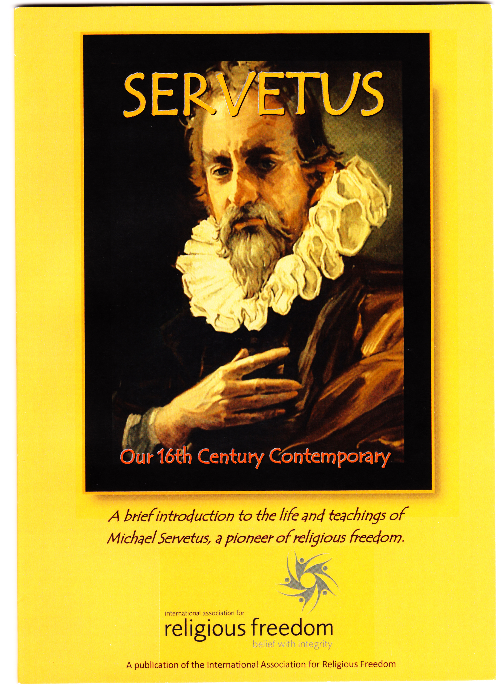
SERVETUS
Our 16th Century Contemporary
Enlightened theologian and peacemaker who sought to reconcile religions and who preached the omnipresence of God, Michael Servetus paid with his life for espousal of tolerance and religious freedom in an age of bigotry.

Calvin’s Geneva saw Servetus and his books burned at the stake. Nevertheless his message of understanding and mutual respect between differing beliefs survives today among all Christian Universalists and the controversies which cost him his life are all too relevant to the religious divisions of our modern world.

In this concise publication seven acknowledged experts combine to offer an authoritative introduction to key aspects of Servetus’ life and teachings. For those who wish to draw on his ideas and his dedication as an inspiration for today’s congregations the book includes a worship resources section freely available for reproduction and use.

Contents
Foreword - English and Spanish (author: Rev. Peter Morales) -- Table of Contents -- Biography of Servetus (author: Jaume de Marcos Andreu) -- Servetus and Islam: In his life (author: Peter Hughes) -- Servetus and Islam: In his writings (author: Jaume de Marcos Andreu) -- Servetus and Unitarianism: The Transylvanian church (author: Rev Sandor Kovacs) -- Servetus and Unitarianism: The Contemporary Legacy (author: Rev.Richard Boeke -- Worship Resources: General Assembly Worship Panel Service ( Rev. Cliff Reed) -- Worship resources: Bilingual Celebration Service (adapted from Servetus Museum original) -- An interview with Servetus (An Imagined talk show, adapted from Calvin and Servetus by Louis W. Jones) -- Selected Bibliography – Appendix: Selections from Servetus’ ‘Restitutio’

July 2011 Paperback A5 Size 68 pages £4.00 (Discount price £3 plus 79p UK postage) from General Assembly of Unitarian and Free Christian Churches
1-6 Essex Street, London WC2R 3HY.
(cheques payable to GA of Unitarian & FCC)
Or Telephone: 44 (0) 20 7240 2384 with credit card details, .

